This is a collection of pictures of my great-uncle Tom Hickman, a well-known Texas Ranger from the 1920s and 1930s. But I’ll start with some videos you can find online. Too bad there is no sound. At age 70, he undertook a couple of trips on horseback to help publicize stock shows.
A script is at https://digital.library.unt.edu/ark:/67531/metadc498715/
and video is at https://digital.library.unt.edu/ark:/67531/metadc1813395/m1/
Here are some screen captures from the trip from Gainesville to Fort Worth:
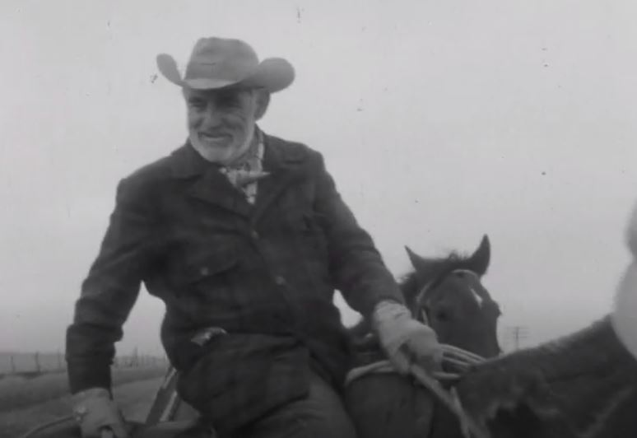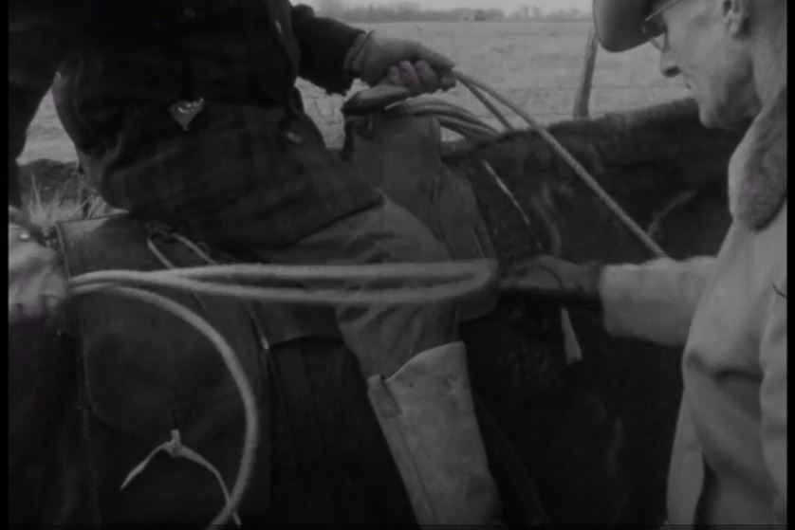
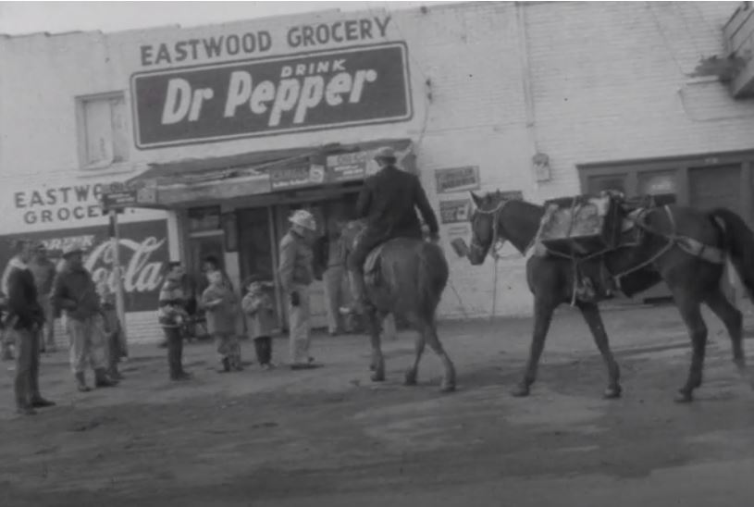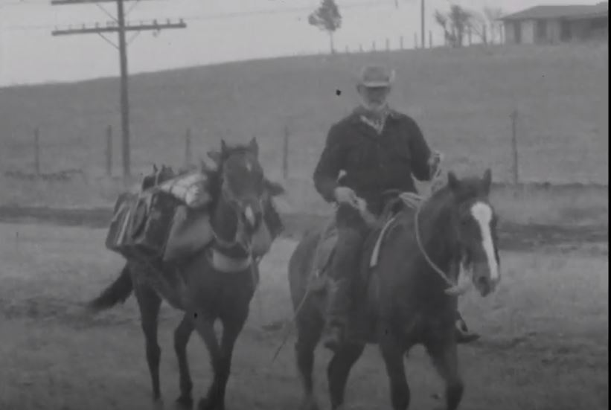
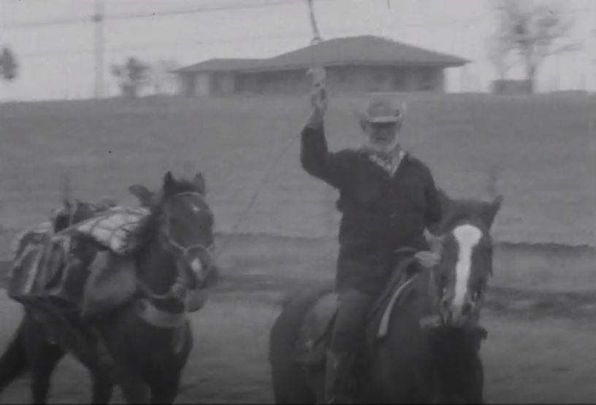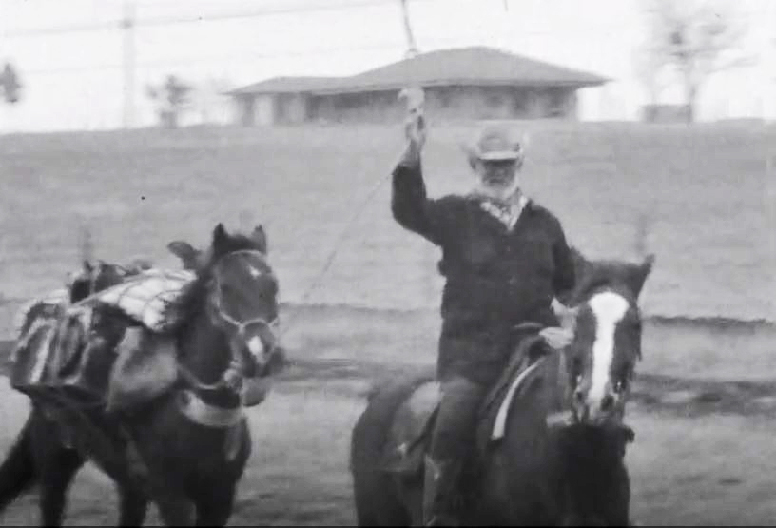
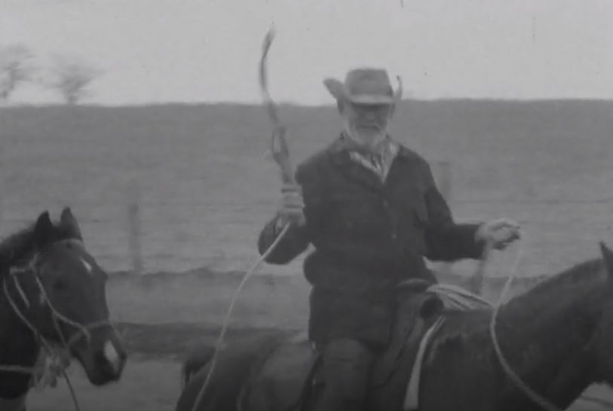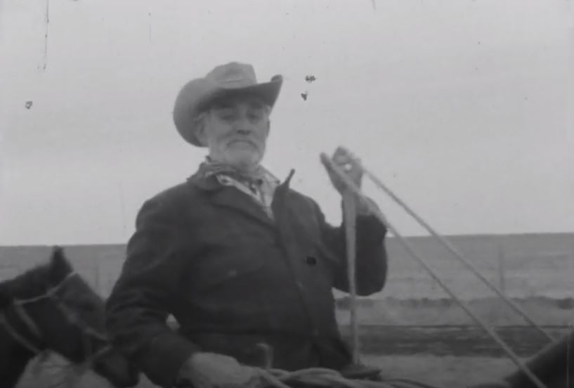
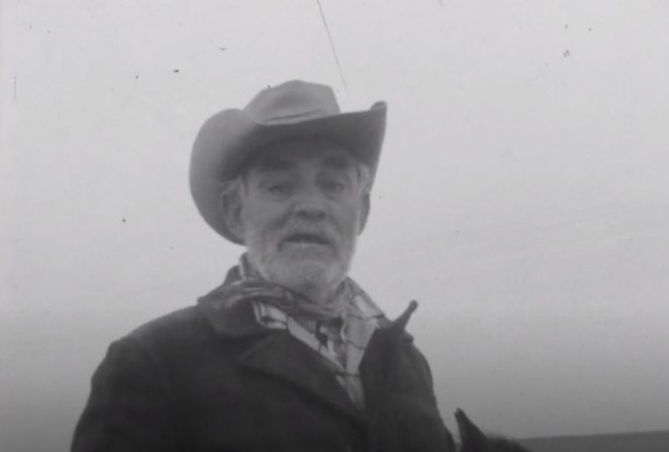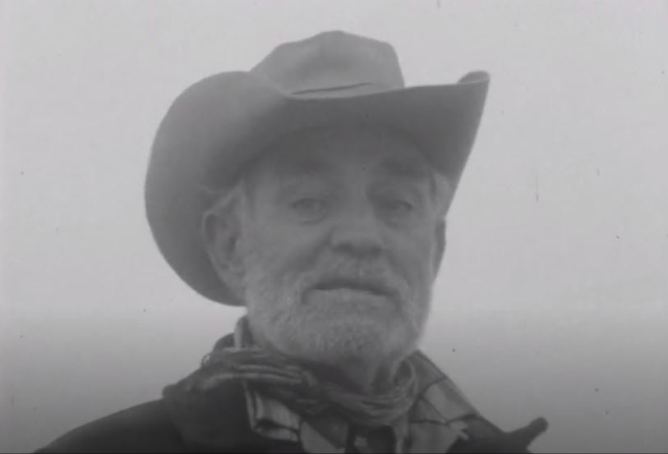
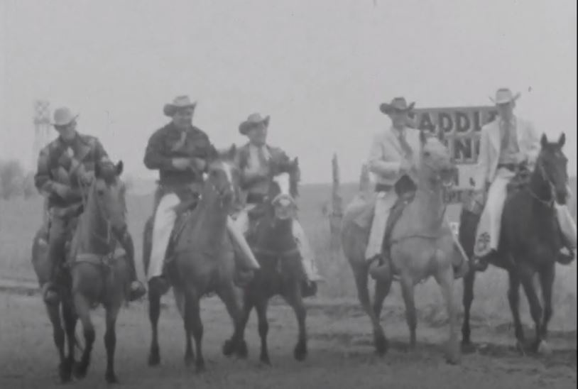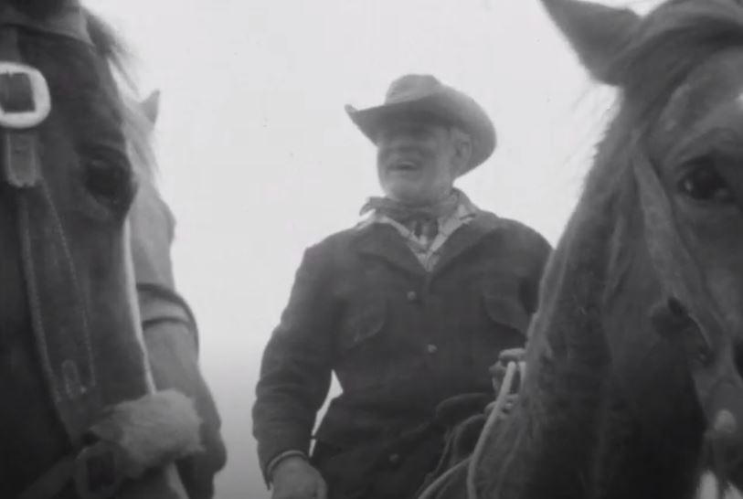
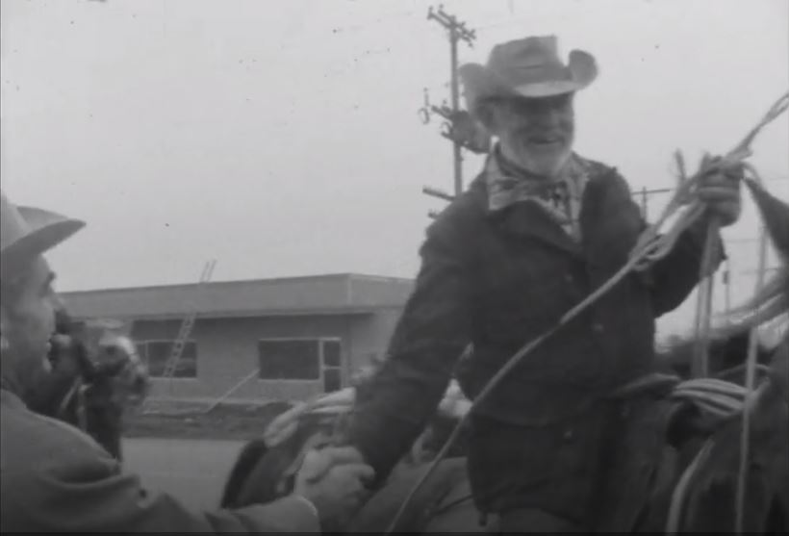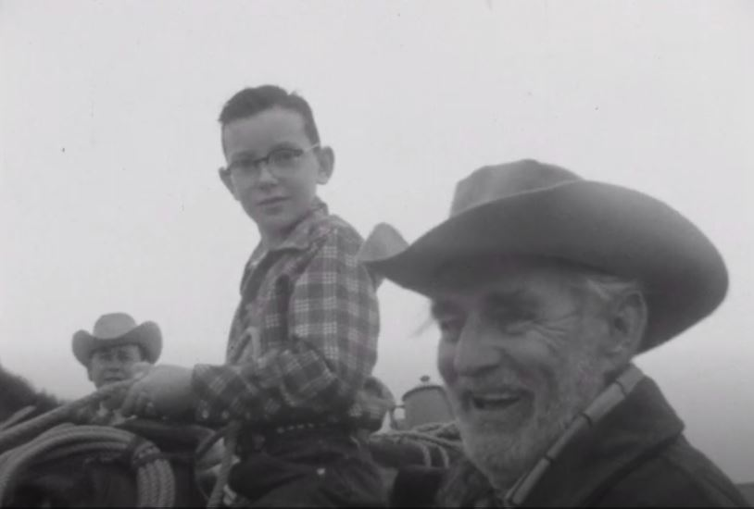
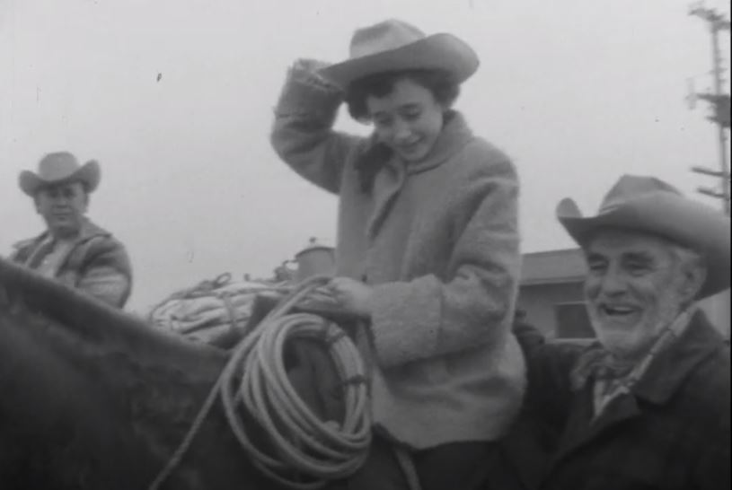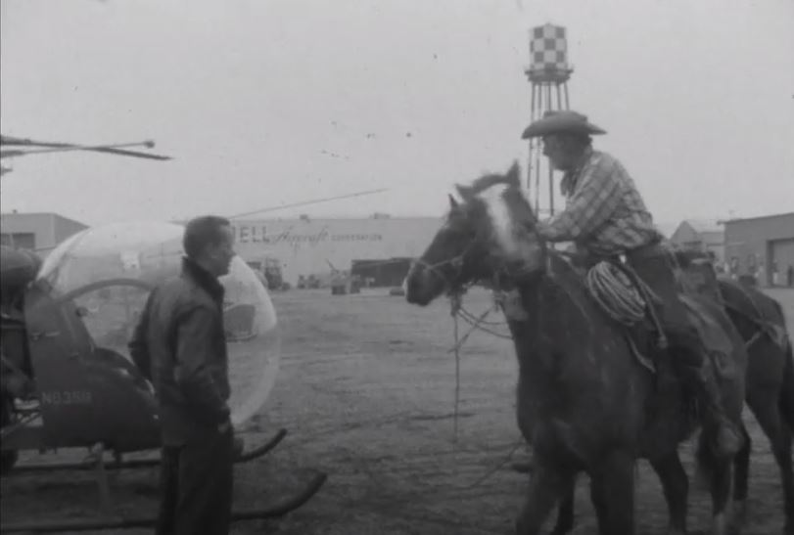
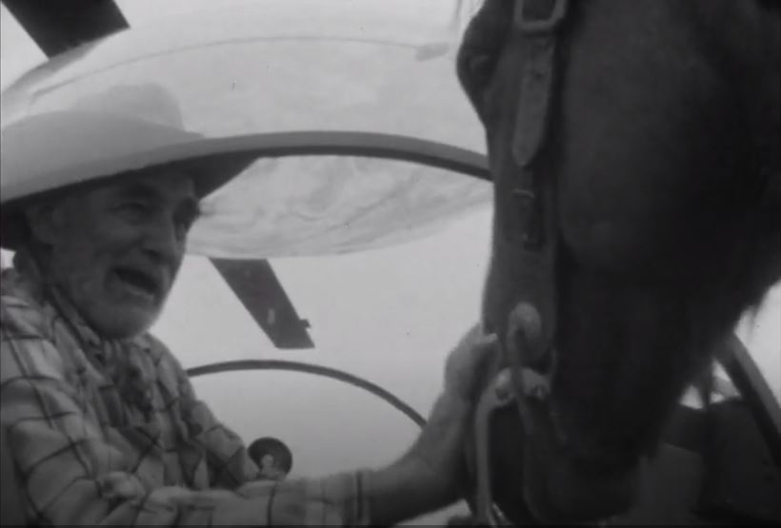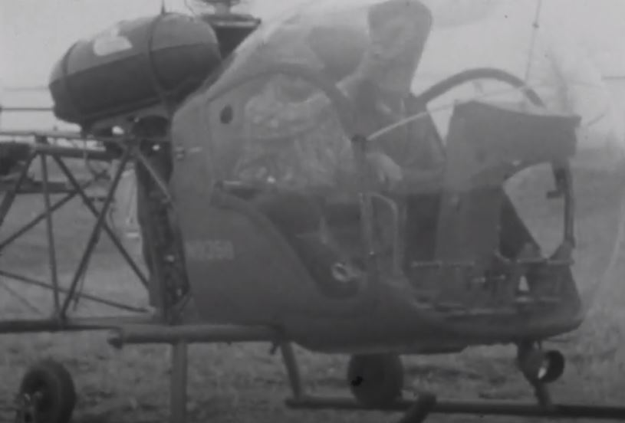
In this first trip he brags about stopping bank robberies at all of the towns along the way. That might not be far from the truth. The Clarksville case is probably the most famous.
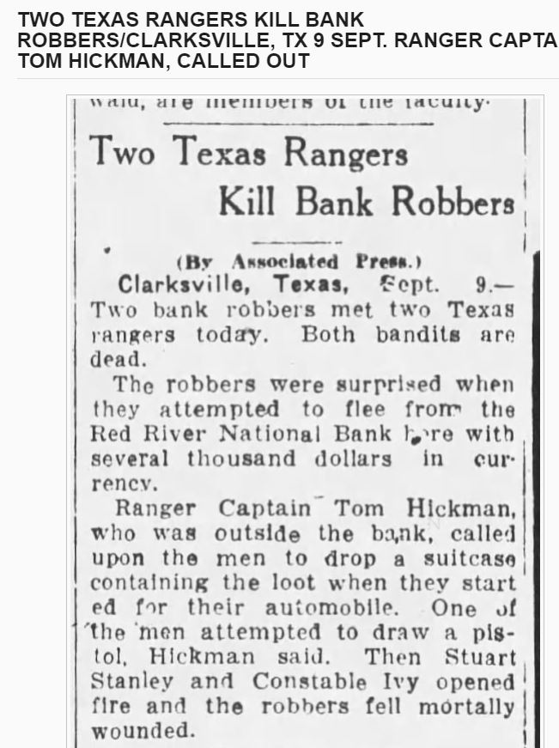
The second trip was Dallas to Waco. The video is here https://texashistory.unt.edu/ark:/67531/metadc1532177/
and there doesn’t seem to be a script. Here are a couple of screen shots.

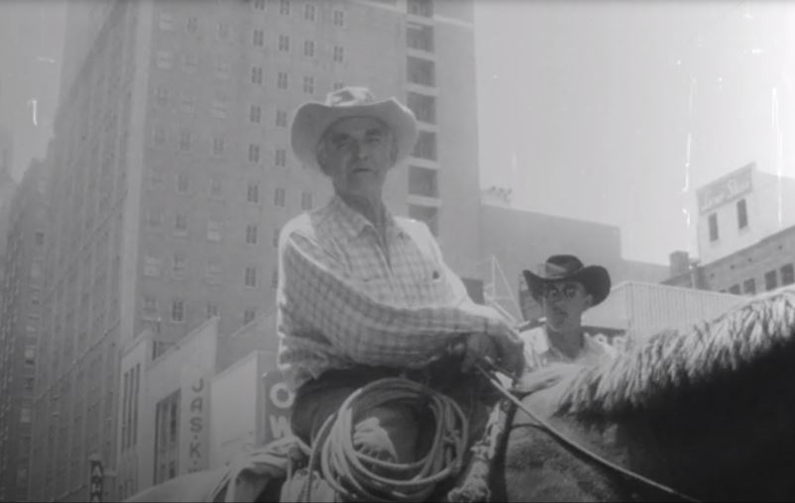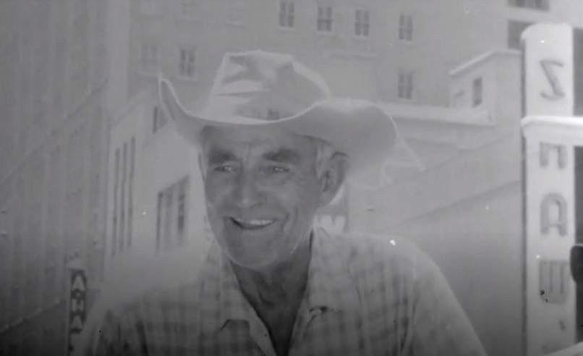
And some TV coverage of his funeral is at https://texashistory.unt.edu/ark:/67531/metadc2541734/m1/
The Miller Brothers 101 Ranch Wild West Show was a Buffalo Bill-like show with cowboys and Indians. Hickman spent a year with the circus, becoming buddies with Will Rogers (picture on right: Hickman, Rogers other), possibly Tom Mix, and others. They toured England in 1908 and performed for King George V.
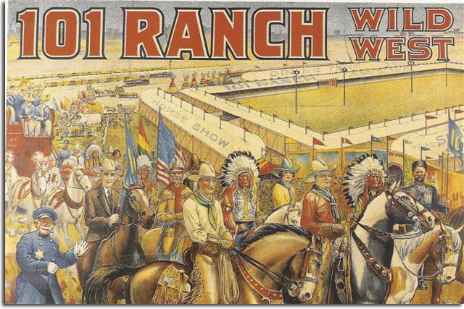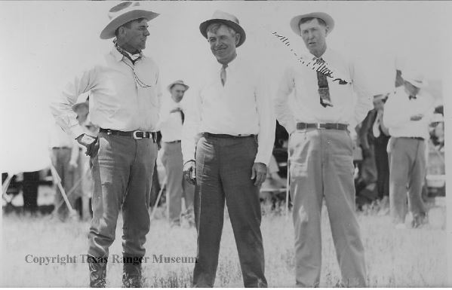
It’s easy to find numerous pictures of Tom Hickman as a Texas Ranger. As it says in the article here https://yohq.org/texas-rangers/hickman he was the “first celebrity Ranger” with his quotability to the press and his rodeo skills. Here are some.
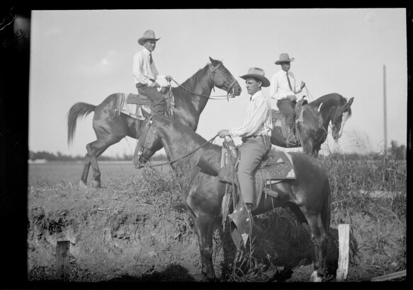 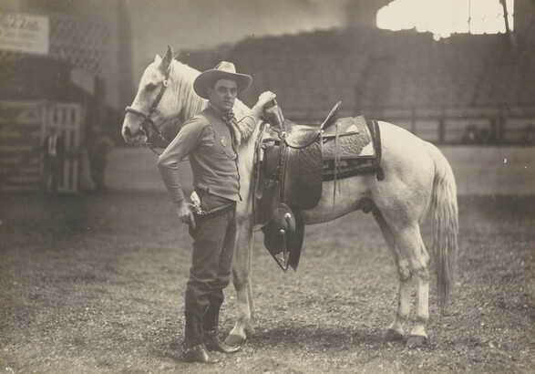
Hickman front
Here is Ranger Company B, of which Hickman was the captain 1920-1933. Hickman is #5, next to Frank Hamer #6.
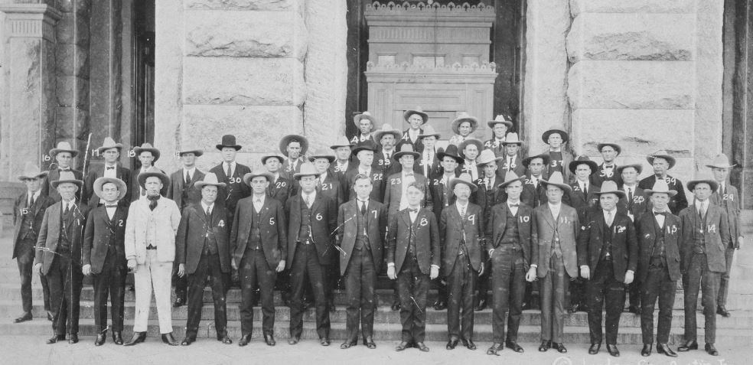
Company B reunion, Hickman third from left next to Manuel “Lone Wolf” Gonzaullas
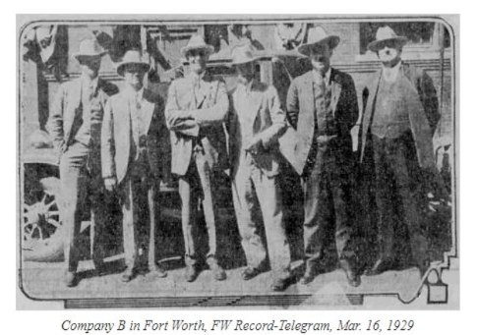
Always with a hat:
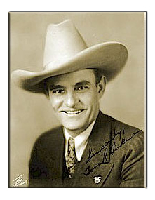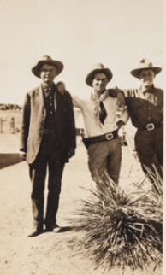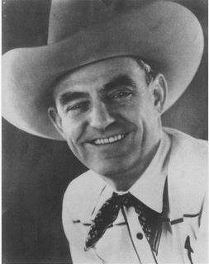
Often with a horse:
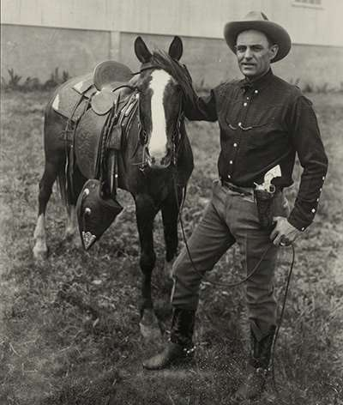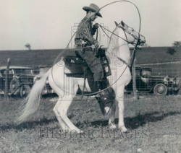
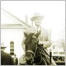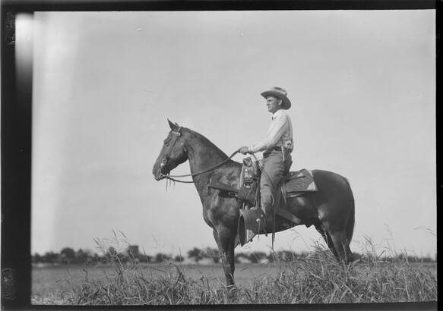
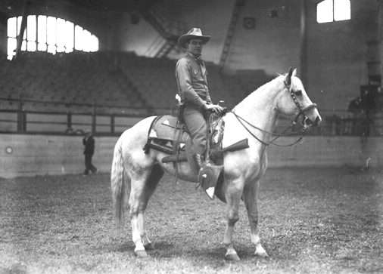
Two pictures credited as being with his wife. His first marriage ended tragically when his wife accidentally shot herself.
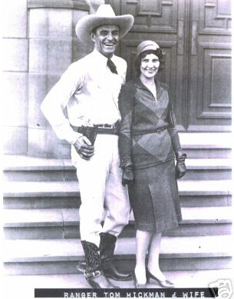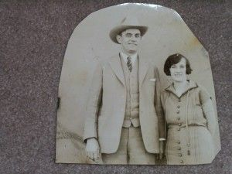
The picture below has been labelled as Hickman with wife and son on a boat to Europe, but I don’t think that the time frame is correct. The trips I have read about were in 1930, a work- and rodeo-related honeymoon, and 1934, 3 years before his eldest son was born. I suspect it is from the 1930 honeymoon and he was posing with one of the child rodeo stars that he was performing with. Here is a story about the 1924 trip: https://yohq.org/ranger-press-clippings/hickman-london-rodeo-1924.
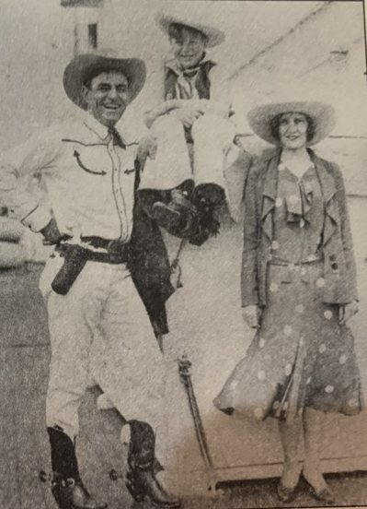
An interesting “story” is behind this picture. Hickman worked hard to put the bank-robbing Story family in jail. And yet, here is Hickman posing with Yancy Story and his new bride.
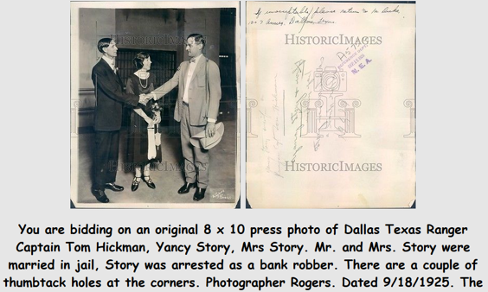
One of the weirdest bank robberies of the time has been immortalized as The Santa Claus Bank Robbery, where one of the robbers wore a Santa Claus suit – he was from that town and didn’t want people to recognize him. Hickman (possibly in the dark suit, white hat) had to calm an out-of-control posse as well as track the robbers.
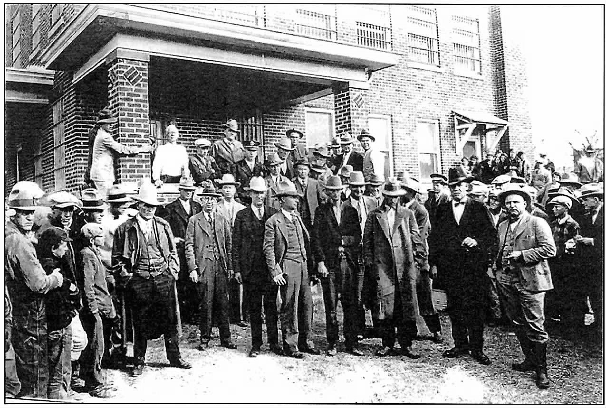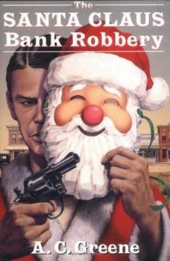
Along with foiling bank robbers, the Rangers in Hickman’s time were busy destroying stills and enforcing Prohibition. On the left are Hickman and Tom Hamer in front of a large still. On the right is a group of Rangers celebrating a major clean-up campaign in Borges, 1927. Hickman is in the center with a victory cigar.
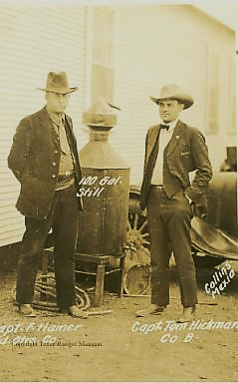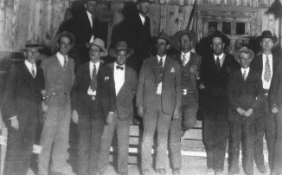

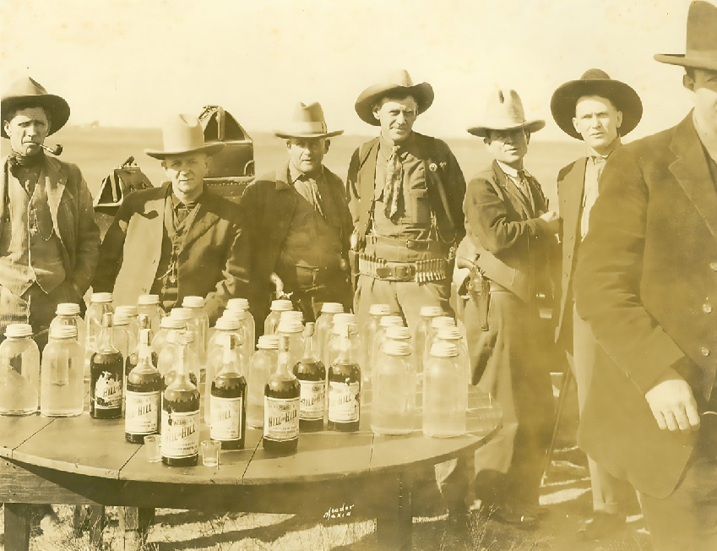
Some artifacts in different museums.
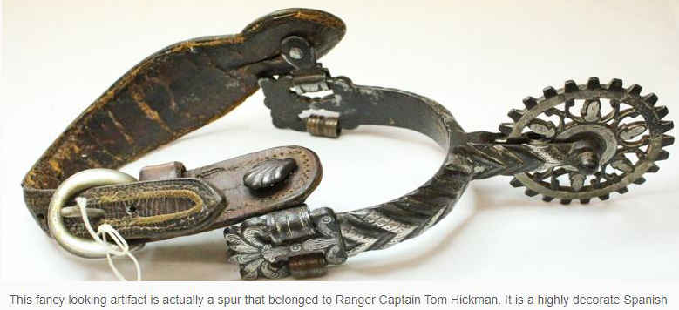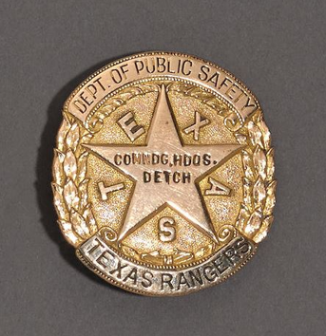
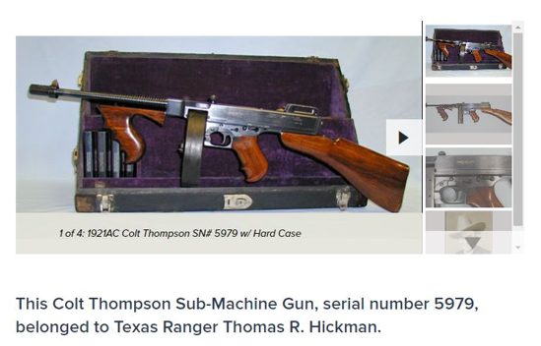
My belt buckle, produced by the Ranger Hall of Fame commemorating some famous Rangers.
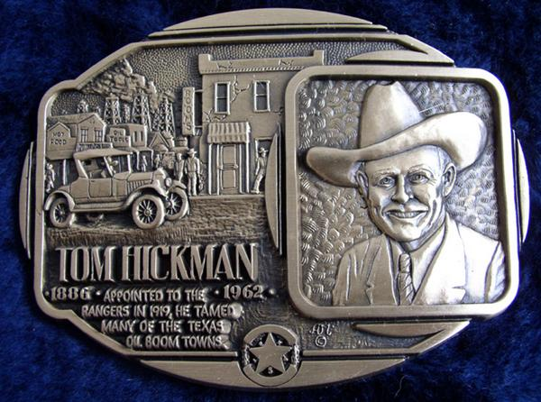
He had an interesting life beyond the Rangers. Here is a picture of the 1905 undefeated Gainesville (Texas) football team. I believe that my grandfather Hickman and his younger brother Tom are on the front row, center and far right.
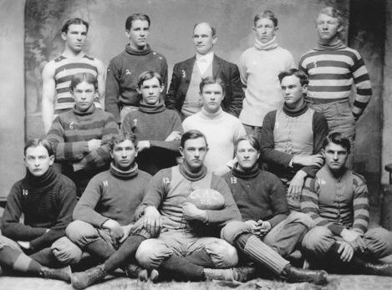
He entertained everyone with rope tricks.
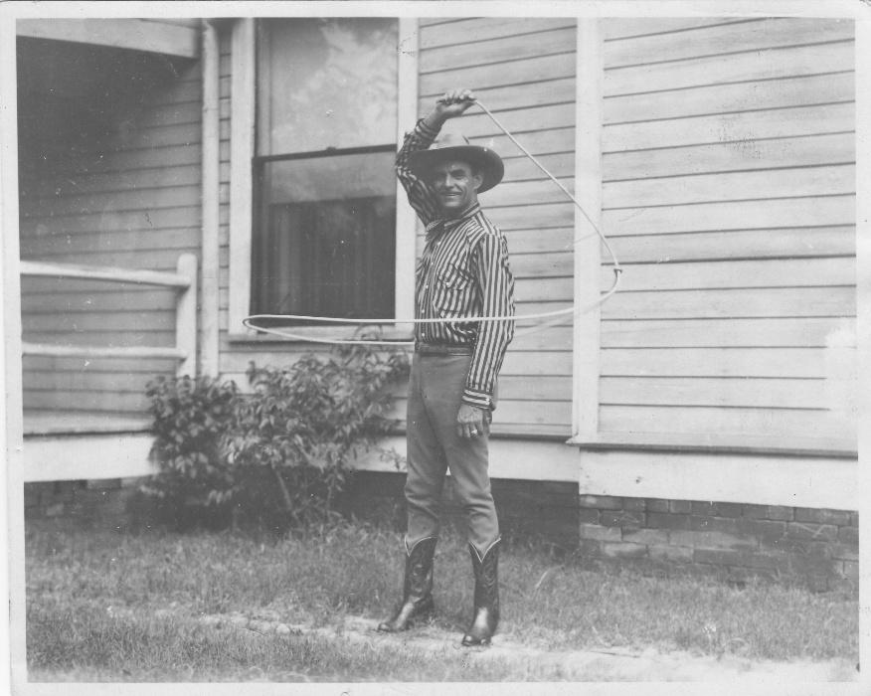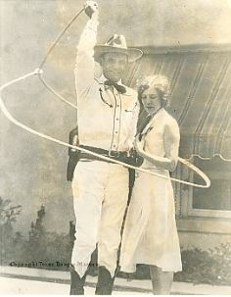
The Southwestern Cattle Raisers Association
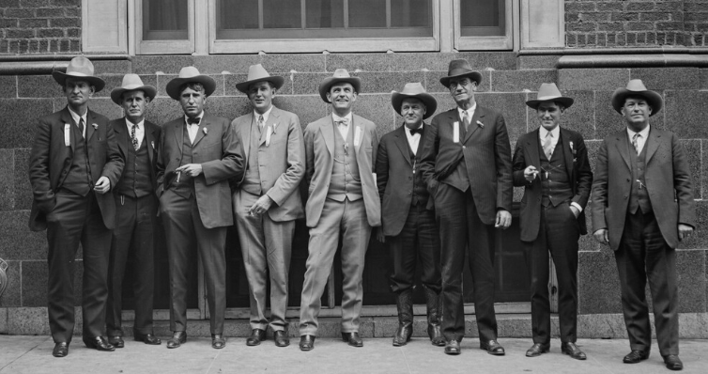
He worked as a rodeo judge and performer for most of his life. In this program from 1932, Hickman is both a judge and a performer in the “Old Timers Roping Contest.” Somebody kept score but I don’t know what it means.
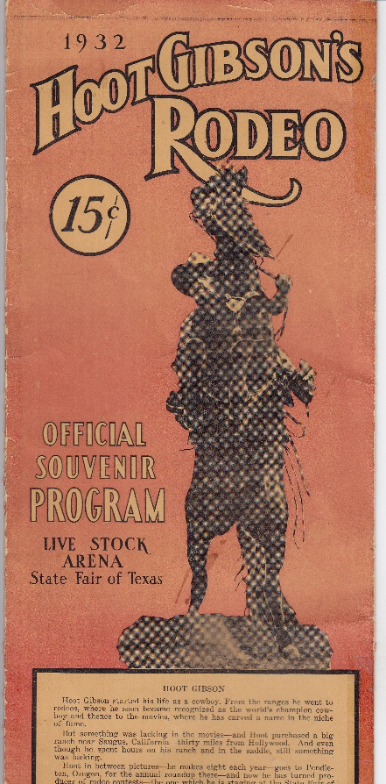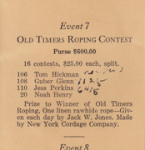
With his family.
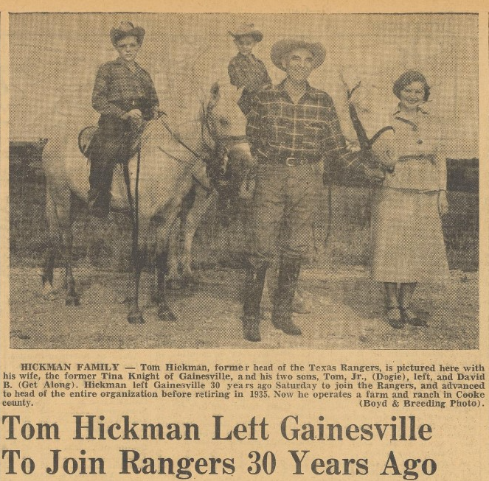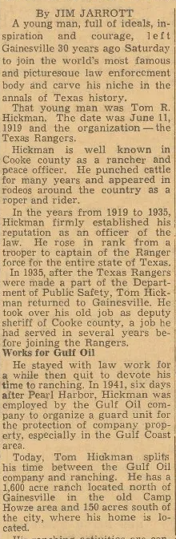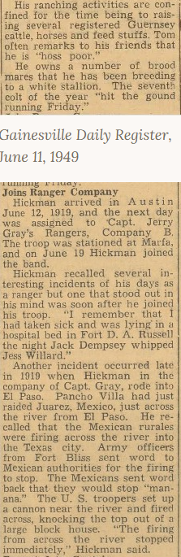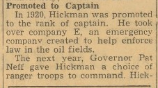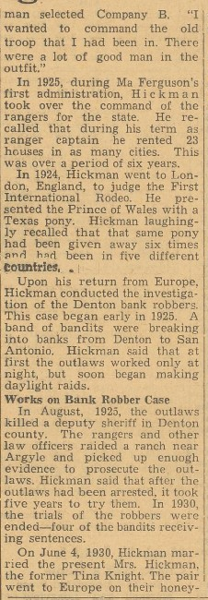
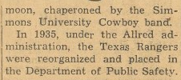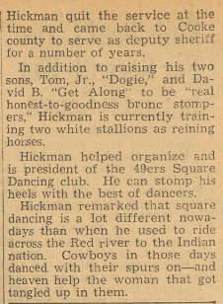
He worked as security for political conventions most of his life. Here he is in 1956 at a state convention not-so-quietly removing a heckling delegate from the hall.
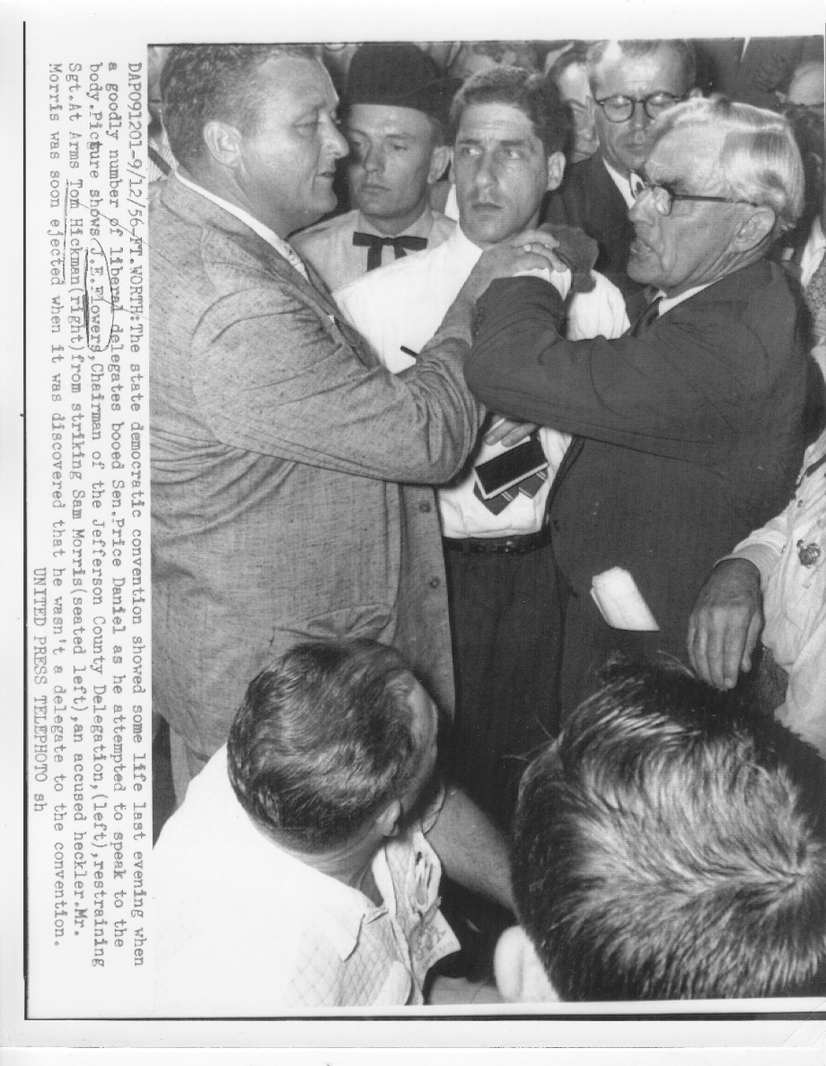
A 1958 gathering of four Ranger Captains: Hickman, Gonzaullas, Crowder, Peoples.
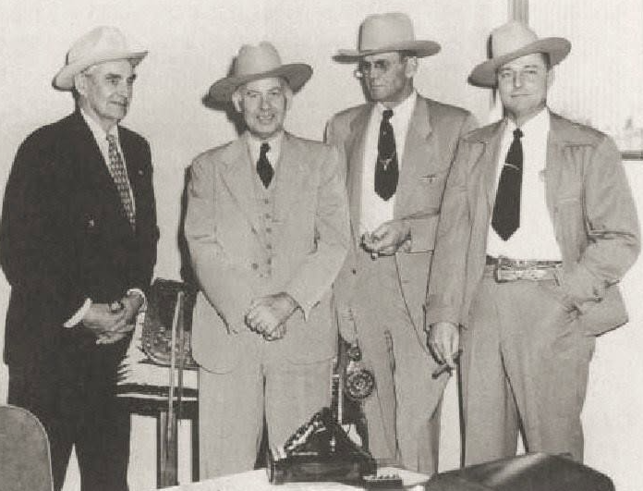
The Texas Ranger statue at Dallas’ Love Field was not modeled after Hickman, but it’s fairly close. The model was a Company B Captain in 1960, who shortly thereafter was forced to resign amid a gambling scandal. Oddly, this is exactly what happened to Hickman. Among other places, you can see the story here: https://yohq.org/ranger-press-clippings/top-o-hill-terrace-hickman-1935.
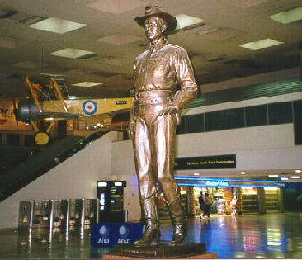
Installed as Chairman of the Department of Public Safety, 1961, shortly before his death.
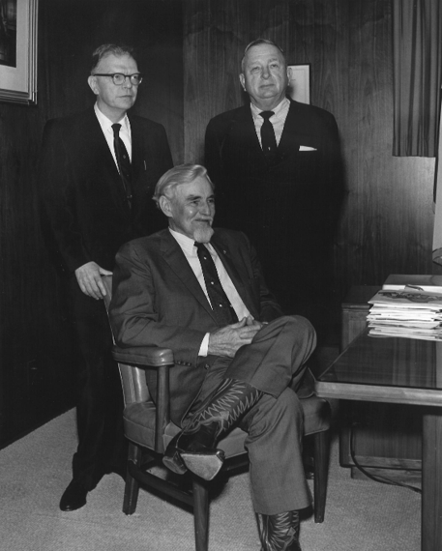
Here are links to stories about Tom Hickman.
https://texoso66.com/2015/06/18/tom-hickman-texas-ranger/
https://yohq.org/texas-rangers/hickman
https://www.texasranger.org/Hall-of-Fame/Hickman-Thomas

